**Hotel Management System**

**Introduction**

It is a website base project. This project is about a five-star hotel management system, in which users can visit the website to know the basic information about the hotel. Users can also book the rooms when they want to stay there. The admin can update the information when it is necessary. Moreover, beautiful dining and meeting rooms are available. A lot of beautiful pictures are available in the gallery.

**Reason of project selection**

There are many reasons to select this project, hotel management system. The reasons of project selection are given below:

* Some problems are faced to get information about a 5-star hotel
* Users can rarely get information about the price of the rooms to stay
* Beautiful dining and meeting rooms are not available in every hotel
* Users can rarely get the pictures of the hotels
* Users face some problems to book the hotels online
* Users cannot know the menu of the foods in the hotel

**Project Requirements**

There are some requirements of this project. They are given below:

**Front-End Design:** Hypertext Markup Language (HTML5), CSS3

**Back-End Design:** PHP

**Hardware Requirement:** Windows 10 Operating System

**Software Requirement:** Notepad++ v7.5.8 (Editor), XAMPP v3.2.2 (Localhost Server with Database)

**Database:** MySQL and PHP MyAdmin

**External Resources:** Books and Internet

**Project Goals**

There are some goals of our project. The goals of project selection are given below:

* To provide information about a 5-star hotel
* To inform the price of the rooms
* To show the beautiful pictures of the hotel
* To provide various information about dining and meeting room
* To book the meetings and rooms online
* To inform about the food menu of the hotel
* To keep information about the users

**Panels**

There are two panels of this project. They are user panel and admin panel.

**User Panel**

In the user panel, there are some features which are necessary for the hotel management system. The features are described below with necessary snapshots.

1. **Home**

This is the homepage of this hotel. In this page, the facilities of this hotel is described. Users can check in and check out in this page. They can also check the availability of their expected room.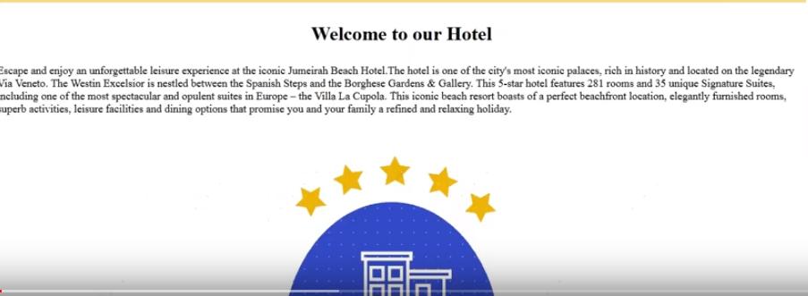

According to guest’s choice, if the room is available, then user can book the room by this feature. Users have to submit their personal information to confirm their stay.

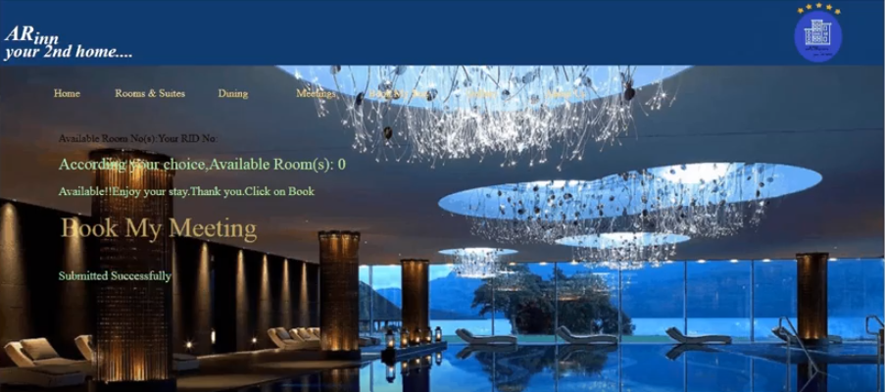

**Figure:** Homepage

1. **Rooms and Suits**

This feature describes the detailed description of the rooms of the hotel. The different types of rooms and their photos are given here.

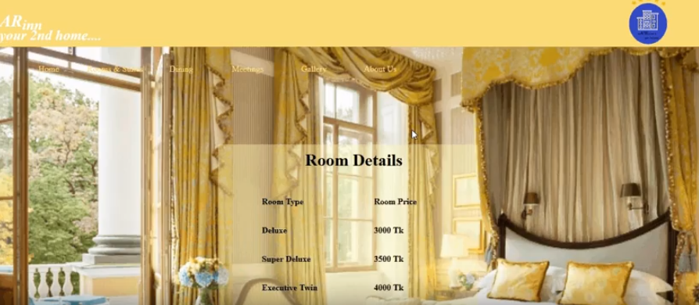

**Figure:** Rooms and Suits

1. **Dining Room:**

This feature describes the detailed description of the dining rooms and food items of the hotel. The various dining rooms with food items and their photos are given here.

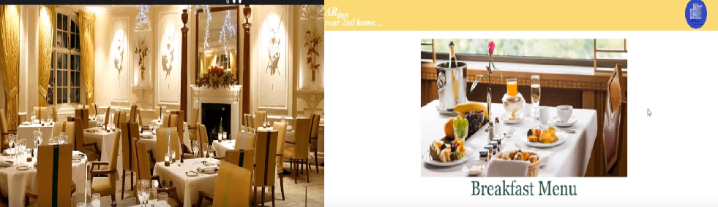

**Figure:** Dining Rooms and Food items

1. **Meetings:**

This feature describes the detailed description of the meetings/events of the hotel. Guests can also check the availability of their preferred meeting/event room.

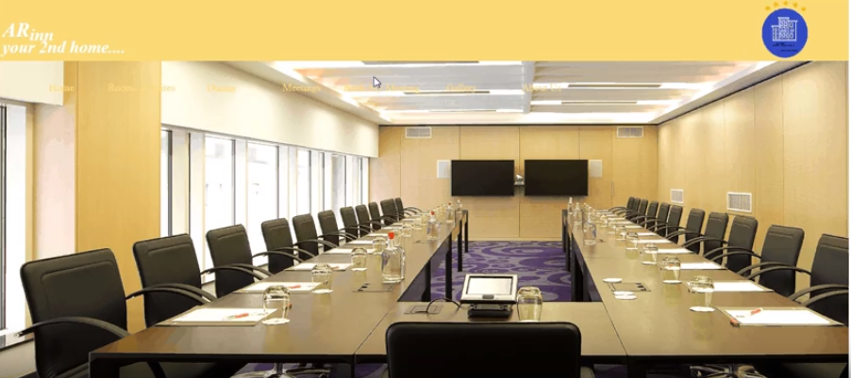

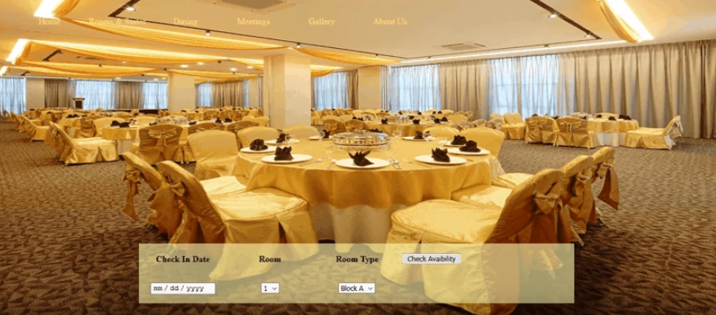

**Figure:** Meeting Room

1. **Map**

This feature shows the location of the hotel by google map.

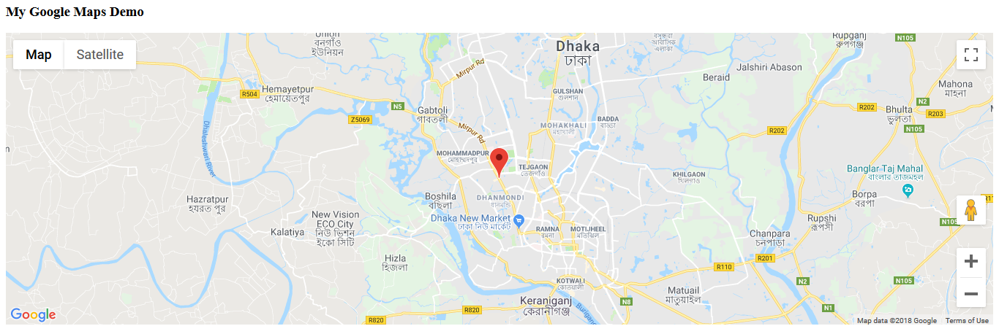

**Figure:** Map

1. **Gallery**

This feature shows the different types of photos of the hotel.

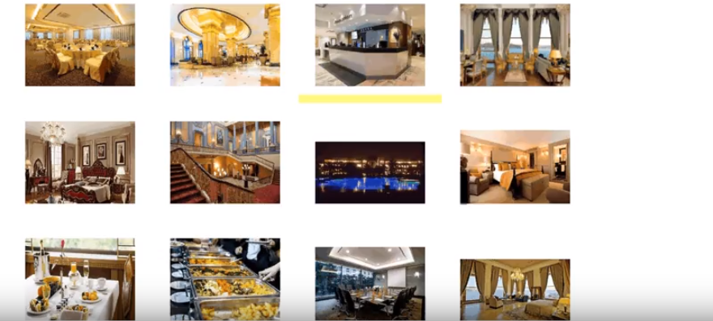

**Figure**: Gallery

1. **About us:**

This feature provides the detailed description of the contact information of the hotel. 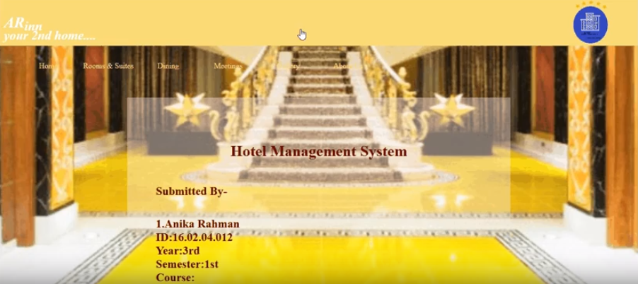

**Figure:** About us

**Admin Panel**

In the admin panel, there are some features which are necessary for the hotel management system. The features are described below with necessary snapshots.

1. **Home**

This is the homepage for the admin of this hotel. 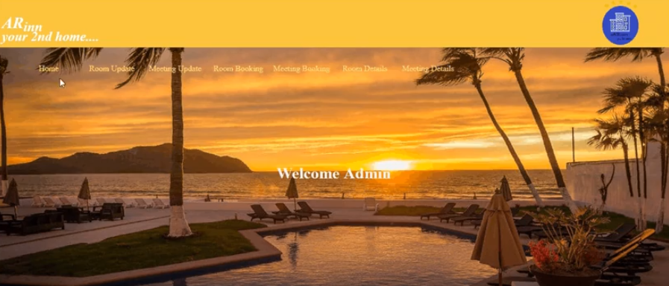

**Figure**: Home

1. **Admin Login**

The admin must log in if he has an account. If there is no account, he must create it.

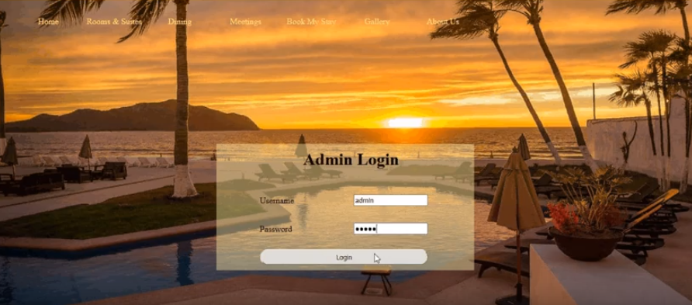

**Figure:** Admin Login

1. **Room Update**

This feature describes the detailed description to update information of the rooms by the admin of the hotel.

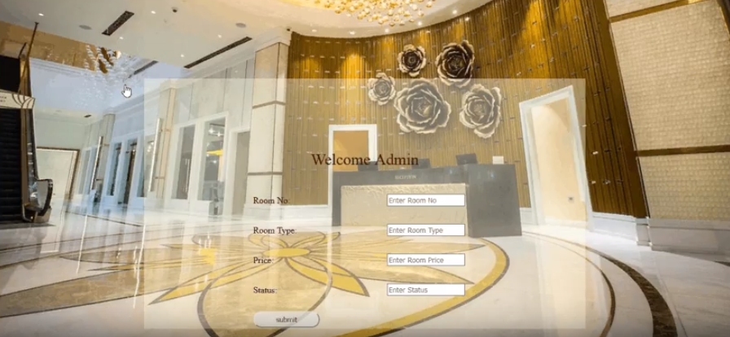

**Figure:** Room Update

1. **Meeting Update**

This feature describes the detailed description to update information the meetings by the admin of the hotel.

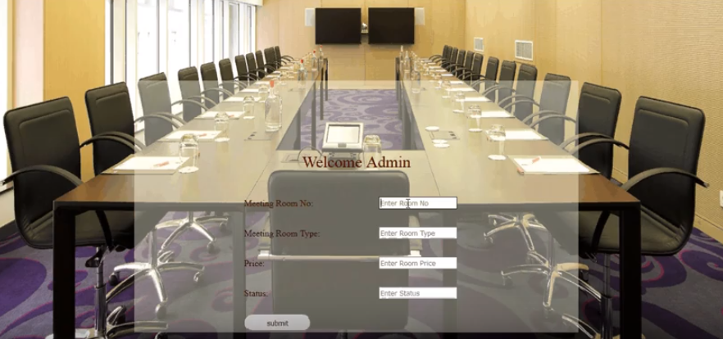

**Figure:** Meeting Update

1. **Room Details**

This feature describes the detailed description the updated information of the rooms. Admin also can know the status of the room. If any guest checks out, then admin clicks on ‘Check Out’ and status will change into ‘Available’.

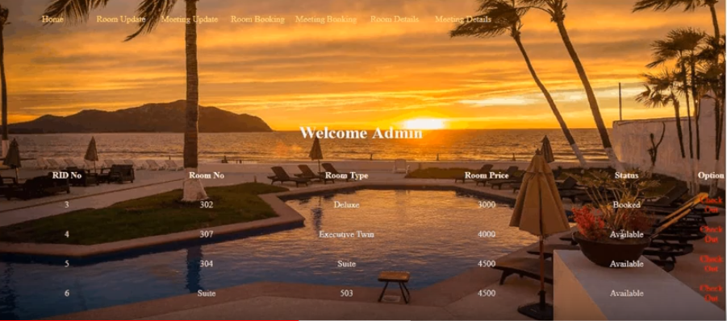

**Figure:** Room Details

1. **Meeting Details**

This feature describes the updated information of the meetings/events by the admin of the hotel. Check Out feature is also available here. 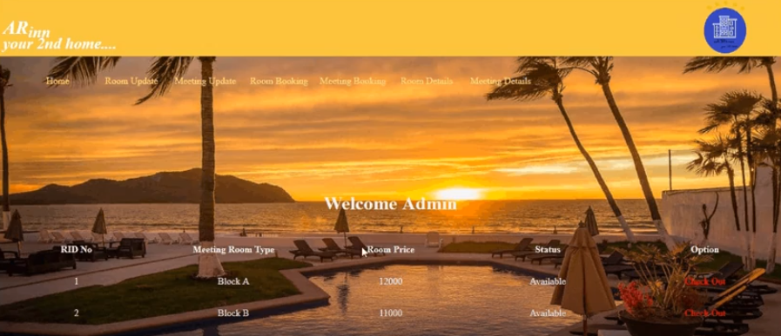

**Figure:** Meeting Details

1. **Room Booking**

This feature describes the detailed description of guests who has booked rooms at the hotel. 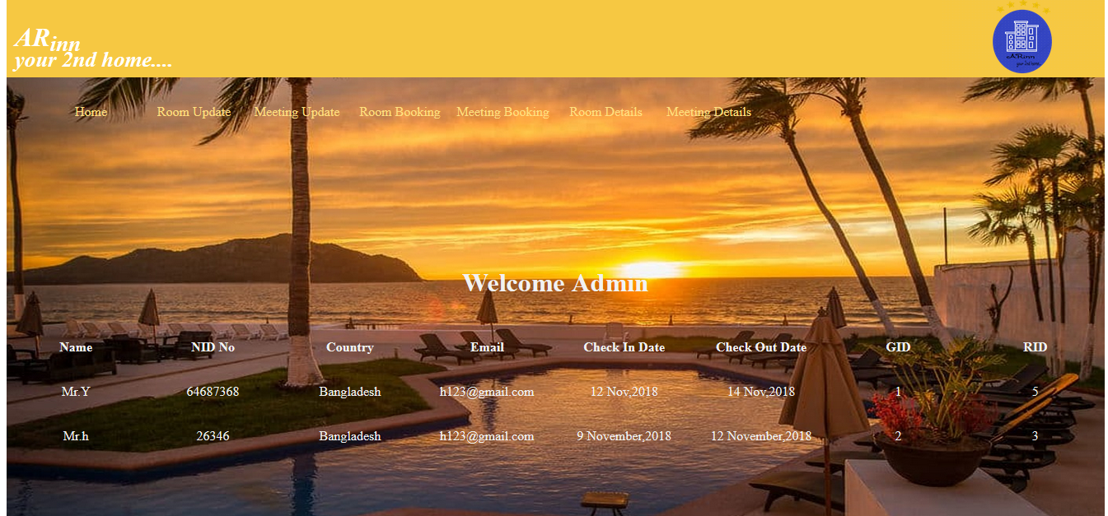

**Figure:** Room Booking

1. **Meeting Booking**

This feature describes the detailed description of guests who has booked Meeting/Event room(s) at the hotel.

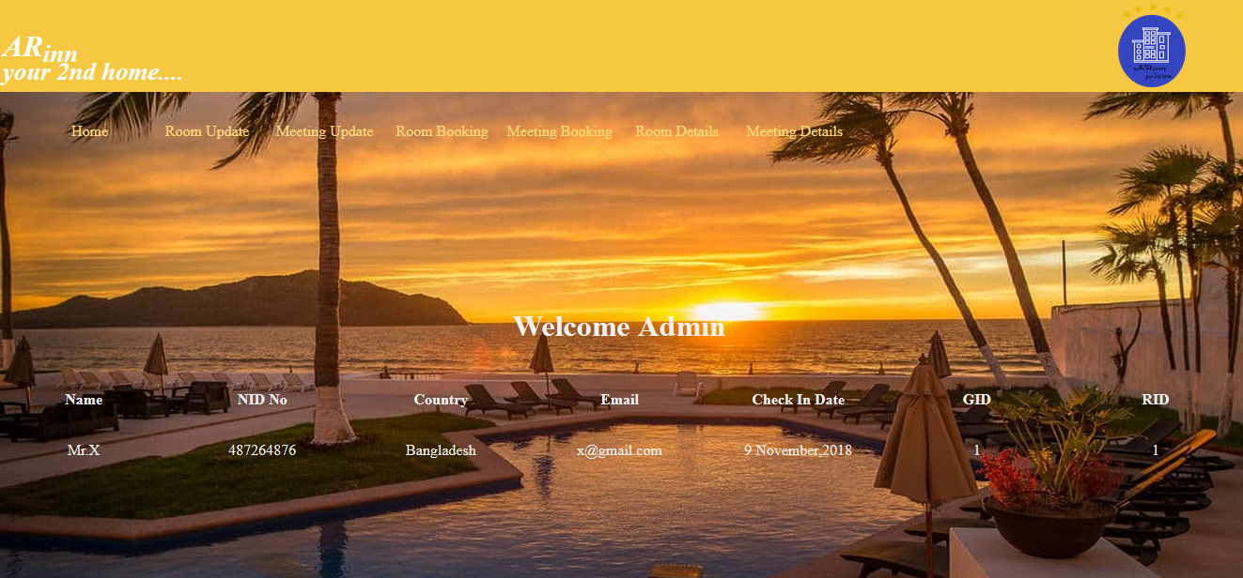

**Figure:** Meeting Booking

1. **Staff Attendance**

This feature describes the detailed information of the attendance of the employee working in the hotel. 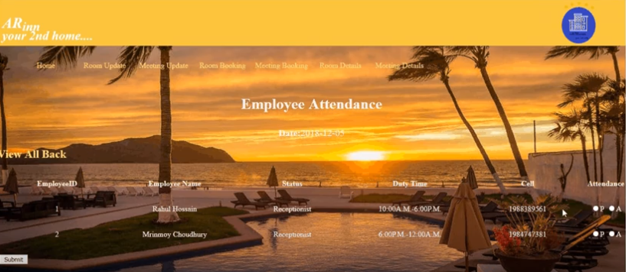

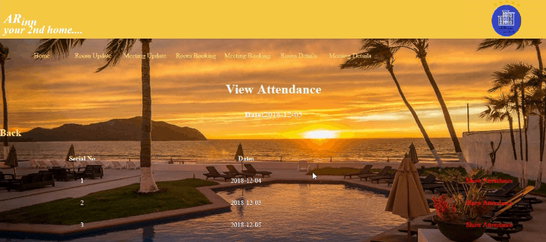

**Figure:** Staff Attendance

1. **Add Employee**

This feature adds the information of the new employees recently joined in the hotel. 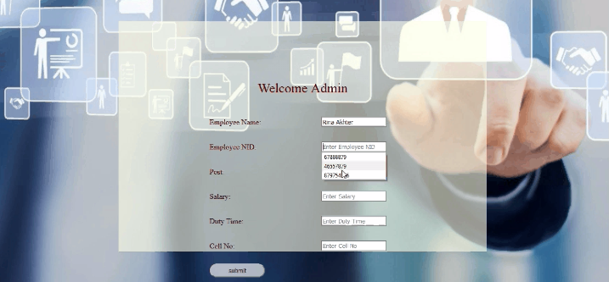

**Figure:** Add Employee

1. **Employee Details**

This feature describes the detailed updated information of the employee who are working in the hotel.

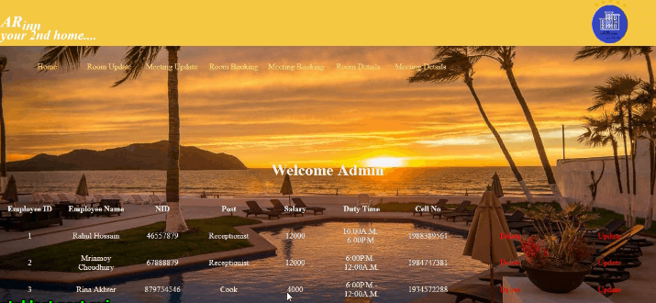

**Figure:** Employee Details

**Features (Summary)**

|  |  |  |  |
| --- | --- | --- | --- |
| No**.** | Feature | Description | Panel |
| 1 | Home | Homepage of this hotel | User |
| 2 | Rooms and Suits | Different types of rooms and their photos | User |
| 3 | Dining | Various dining rooms and their photos | User |
| 4 | Meetings | Detailed description of the meetings/events of the hotel | User |
| 5 | Map | Shows the location of the hotel by google map | User |
| 6 | Gallery | Different types of photos of the hotel | User |
| 7 | About us | Contact information of the hotel | User |
| 8. | Home | Homepage for the admin of this hotel | Admin |
| 9. | Admin Login | The admin must log in if he has an account | Admin |
| 10. | Room Update | Provides updated information of the rooms by the admin of the hotel | Admin |
| 11. | Meeting Update | Provides updated information of the meetings by the admin of the hotel | Admin |
| 12. | Room Details | Check out information (rooms) of the guests | Admin |
| 13. | Meeting Details | Check out information (meetings) of the guests | Admin |
| 14. | Room Booking | Detailed description of guests who has booked rooms at the hotel | Admin |
| 15. | Meeting Booking | Detailed description of guests who has booked Meeting/Event room(s) at the hotel | Admin |
| 16. | Staff Attendance | Detailed information of the attendance of the employee | Admin |
| 17. | Add Employee | Adds the information of the new employees recently joined | Admin |
| 18. | Employee Details | Detailed updated information of the employee | Admin |

**Entity Relationship Diagram**

**Description**

|  |  |
| --- | --- |
| **Table Name** | **Attributes** |
| Admin | un, ps |
| Form | id,name,rid,address,country,email,cidate,  codate,members,adult,child,idno |
| Room | id,rno,rtype,rprice,status |
| Mform | id,name,rid,address,  country,email,cidate,members,idno |
| Mroom | id,rno,rtype,rprice,status |
| Employee | id,name,NID,type,salary,time,cell |
| Attendance | Id,employee_ID,employee_Name,  attend,atnd_time |

**Diagram**

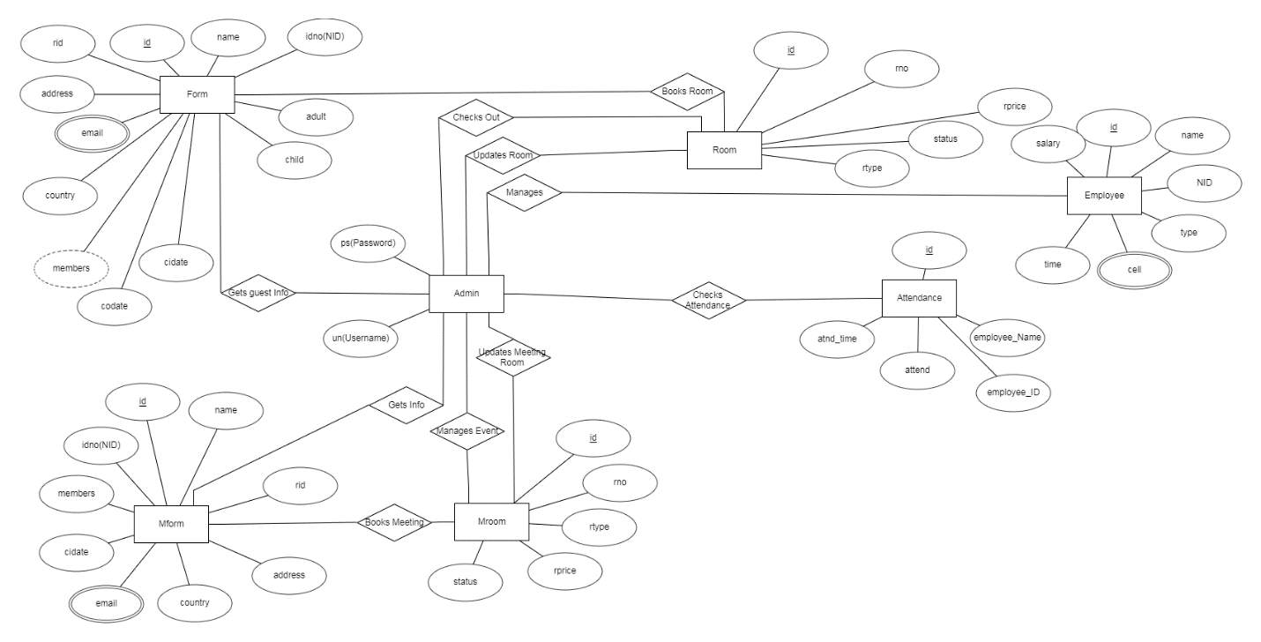

**Figure:** Entity Relationship Diagram

**Future Plan**

Our future plan in this project is to implement the weather forecast. It isn’t possible to implement at this moment because some advanced processes are required to implement this feature. These advanced processes are not available at this moment. So, we need to implement this feature in future.

**Conclusion**

That’s all about the project we have done so far. We have completed this project before the final submission as possible as we can. We hope, this project will help the users and it will be helpful to enjoy the stay for the users. Thank you so much.